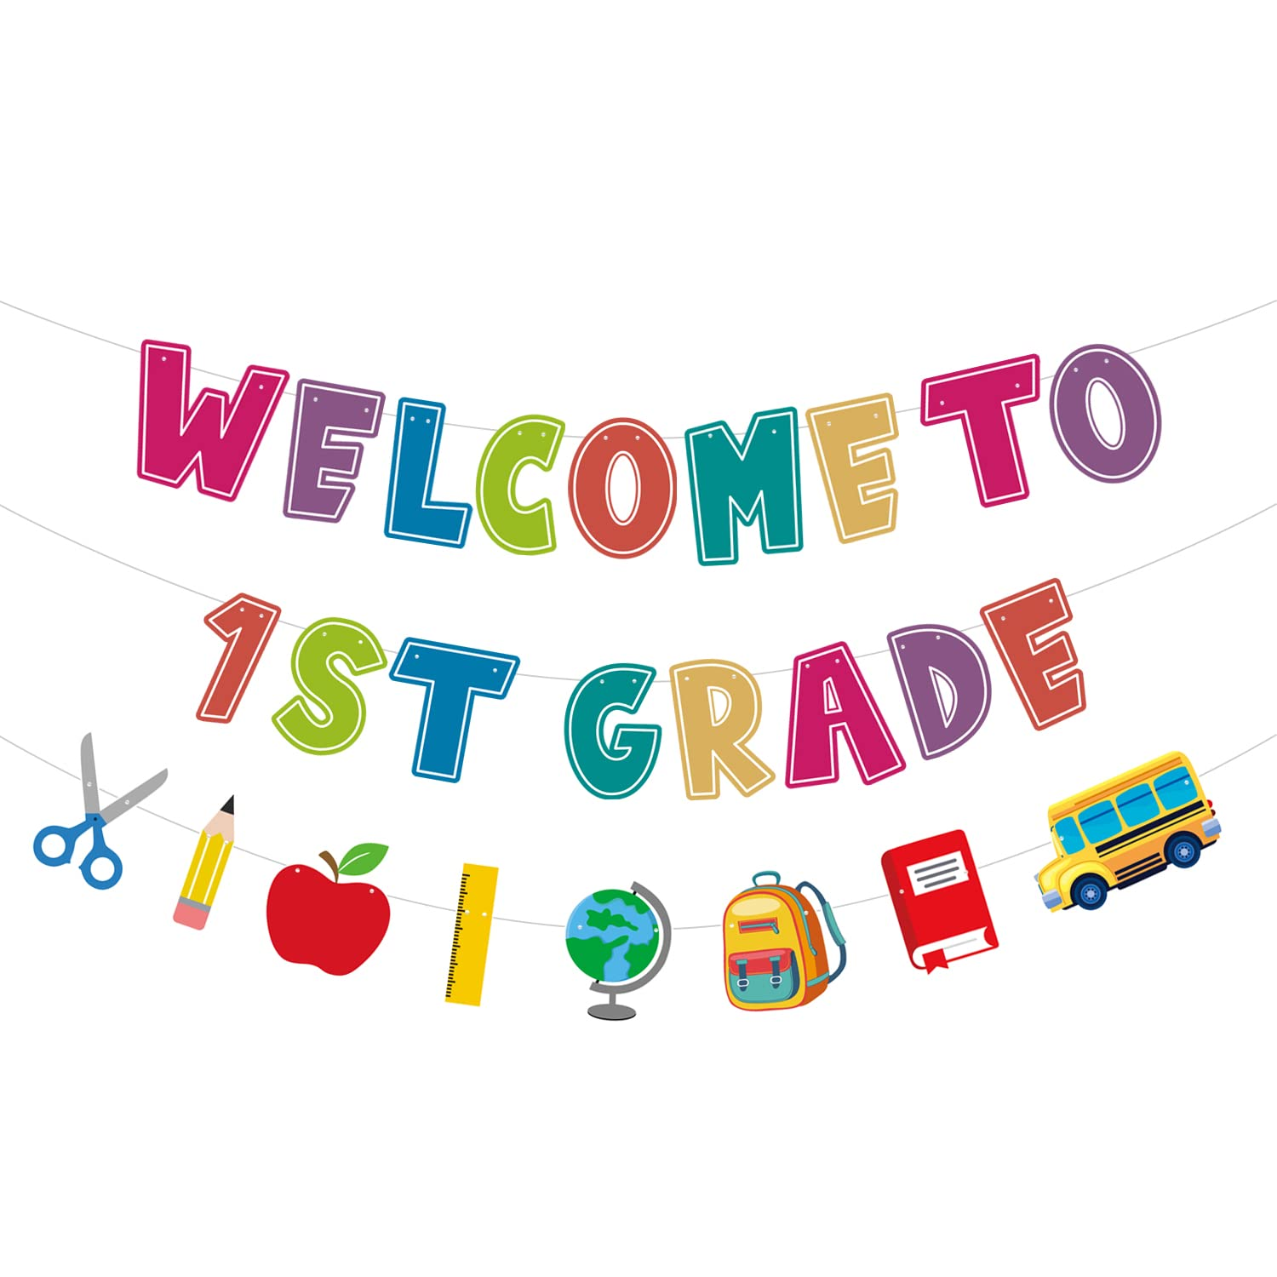
Dear Families,

Welcome to first grade! My name is Mrs. Lauren Hannon, and I will be your child’s teacher for the 2024-2025 school year. This year will be my 20th year at Mill Creek and my 21st year in the Central Bucks School District. First grade is such a special time, and I look forward to guiding your child as they learn and grow throughout the school year!

I am a graduate of Pennsylvania State University where I received my bachelor’s degree in Elementary Education with a minor in Sociology. I earned my Master’s Degree in Education from Arcadia University, and my program there focused on using literature to teach reading and writing. I am a huge sports fan and enjoy going to Phillies and Penn State games. I love reading, traveling, and spending time with my family. My husband and I are blessed with two amazing sons. Our oldest son, Alex, is 13 and keeps us on our toes. While he enjoys all sports, his number one love is baseball. He will be in 8th grade at Holicong this fall. My youngest son, Gregory, is nine and is entering 4th grade at Buckingham Elementary School. He is our social butterfly and makes us laugh each day. Between the two of them, most of my free time is spent on either a football or baseball field. This year we were fortunate enough to travel to Alaska and visit family in Myrtle beach. As you learn more about me, I hope to learn more about your child and family.

Starting first grade can be a big step for many students, as it may be the first time they are away from home for an entire day. I am here to support you and your child. We will spend our first few weeks learning about each other and working together to create a classroom community. This year students will participate in morning meetings and closing circles. We will use this time to turn our classroom into a family and reflect on our day’s accomplishments and successes. We will have something to celebrate each day! GRIT is something that I emphasize in 1st grade, and I am excited to have students learn about and demonstrate this throughout the year.

I encourage you to contact me with any questions or concerns you or your child may have as we begin our year together. Feel free to email me at lhannon@cbsd.org. I’ll be happy to answer any questions and ease any anxieties as best I can. Enjoy these remaining days of summer! Create some wonderful family memories, relax, and be ready for a new and fantastic first grade year. I look forward to working with you and your child. Welcome to first grade and Team Hannon!

Warmly,
Lauren Hannon

